

**PRATHMESH PATIL**

**A71004819033**

**BCA SEM4**

**UI / UX**

AMITY UNIVERSITY MAHARASHTRA

Amity Institute of Information Technology

This is to certify that Mr. Prathmesh Patil is a Bonfire student of Amity Institute of Information Technology, at Amity University Maharashtra and he has done the project work titled “UI / UX” at Amity University Mumbai as prescribed by AIIT, AUM in partial fulfilment of the requirement of BCA Program for the academic year 2021-22.

Teacher’s signature :-

**INDEX:-**

|  |  |  |
| --- | --- | --- |
| Index No | Experiments | Page no |
| 1 | GUI tool kits(wireframe) | 3 |
| 2 | Creating a page | 5 |
| 3 | Prototype | 8 |
| 4 | Slider | 10 |
| 5 | Project | 11 |

Experiment 1:-

Aim:-Installing Wireframe tools on Adobe XD

Scenario:-

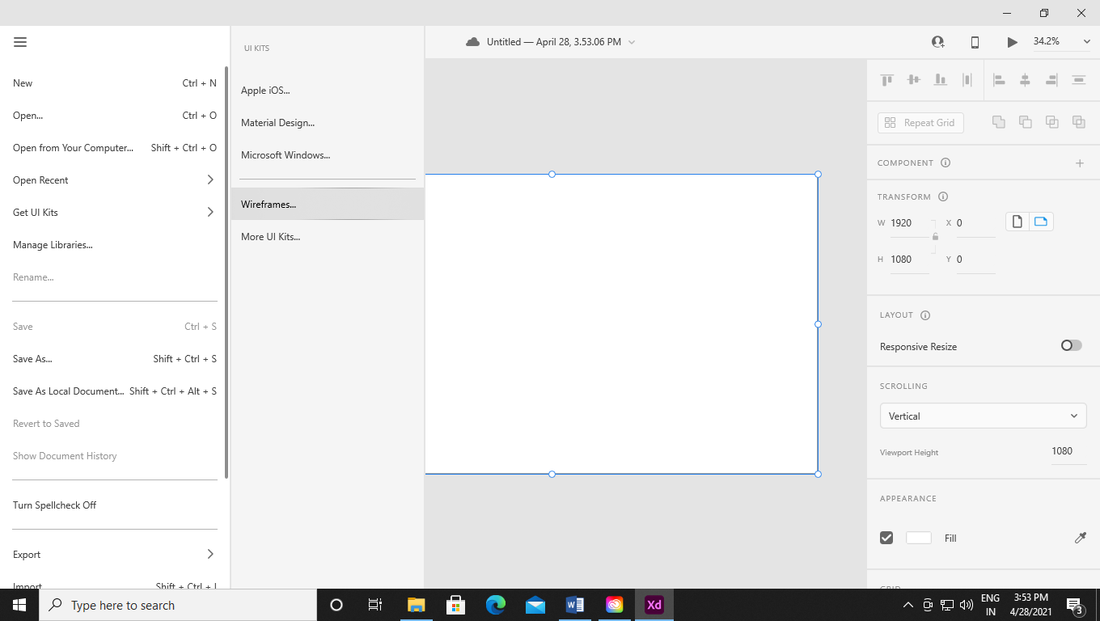

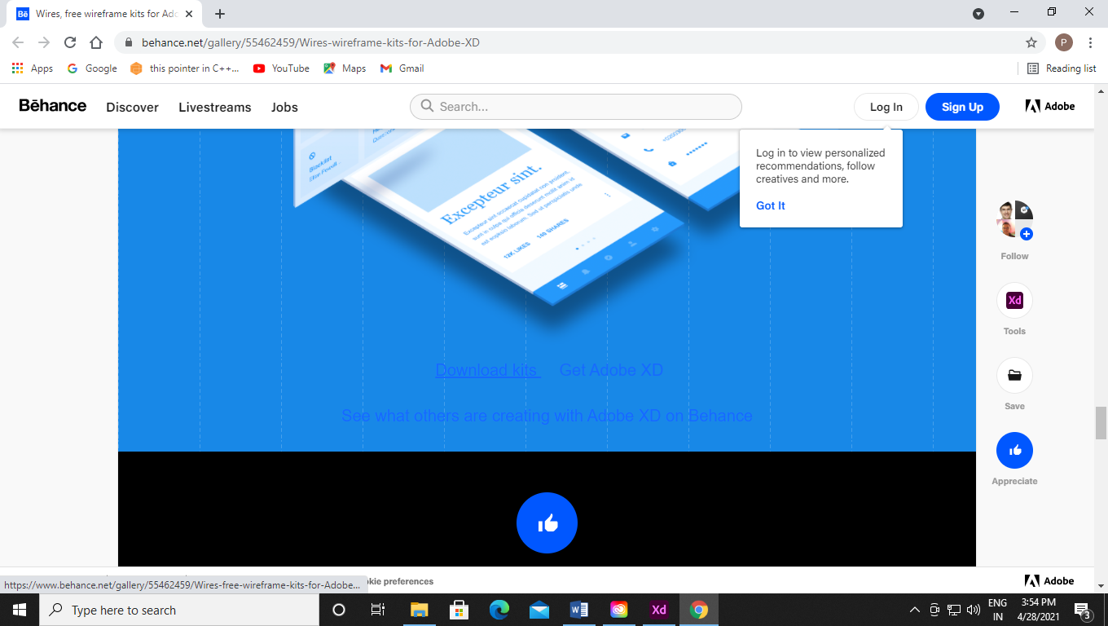

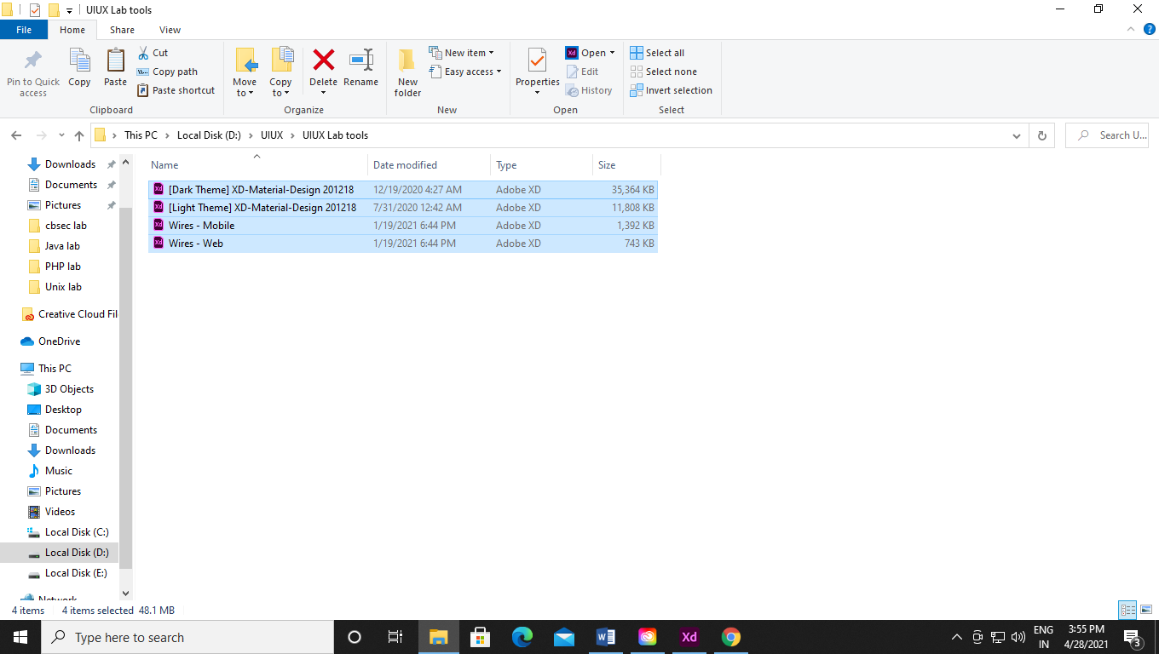

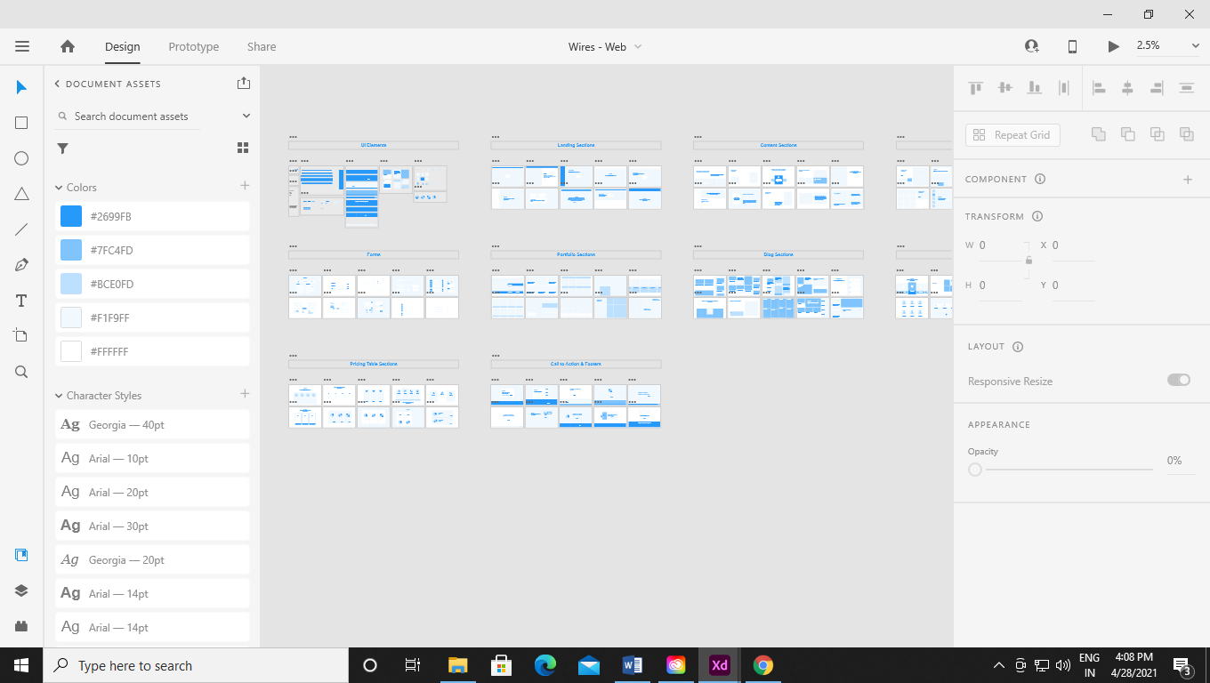

Experiment 2:-

Aim:-Making a form page from wireframe tools.

Scenario:-



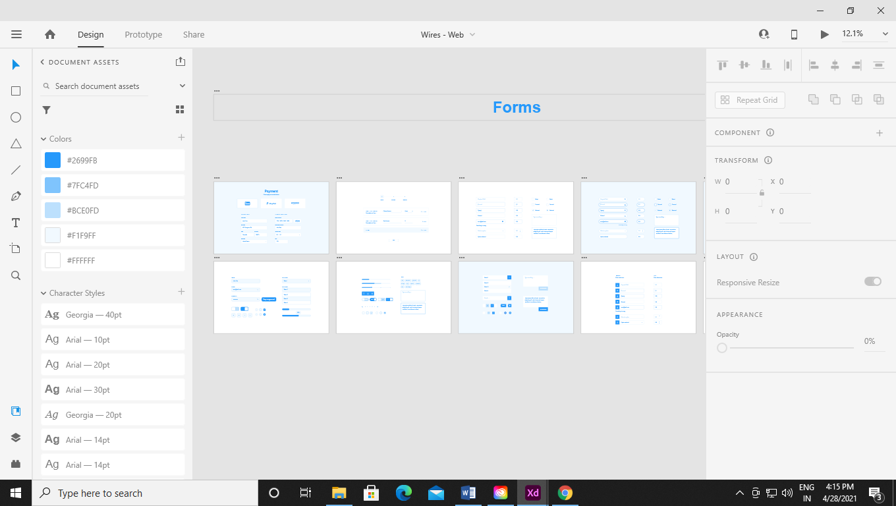

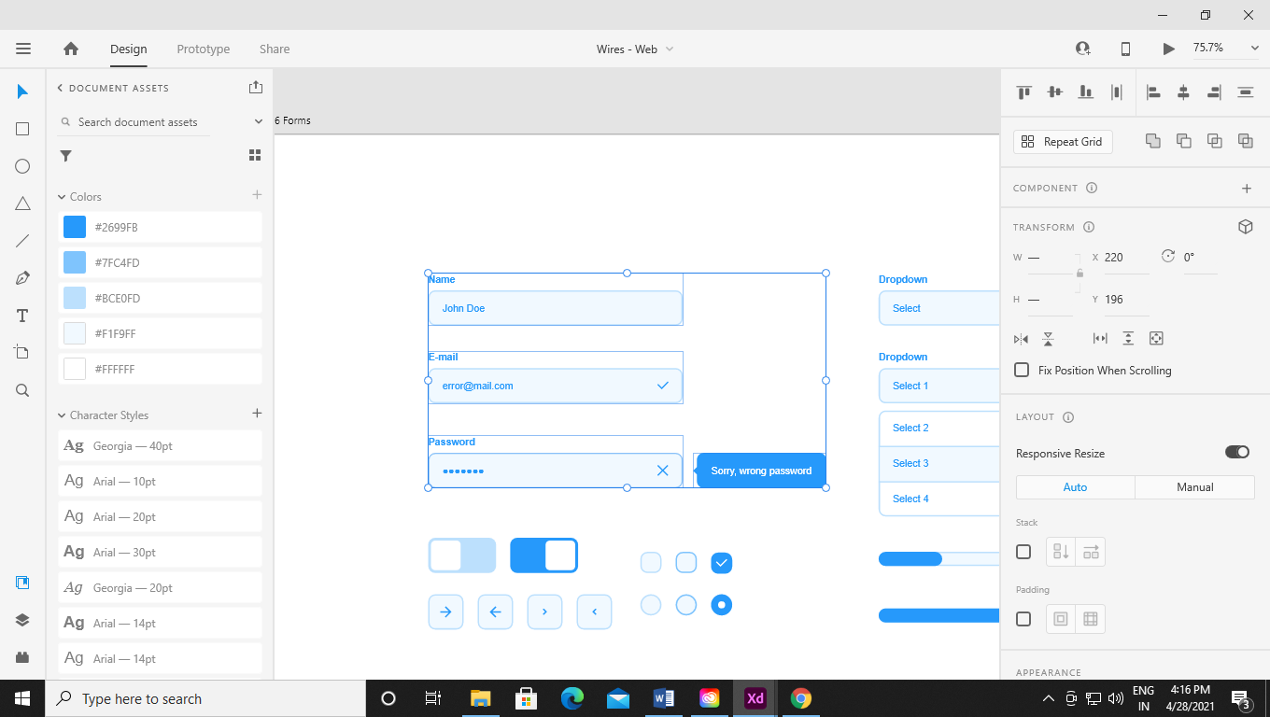

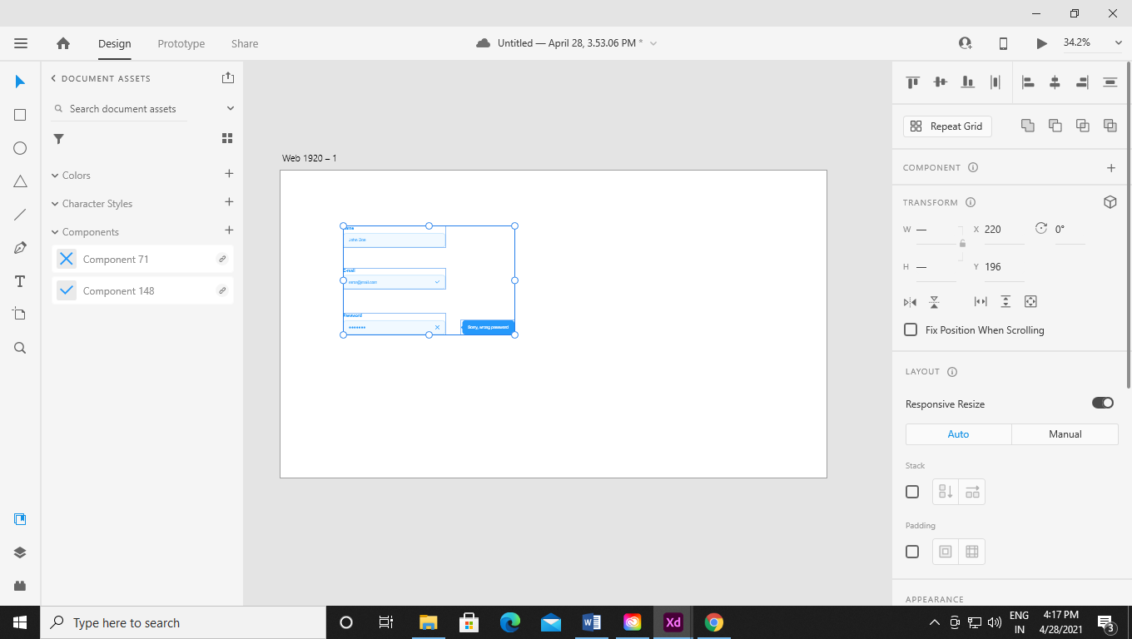

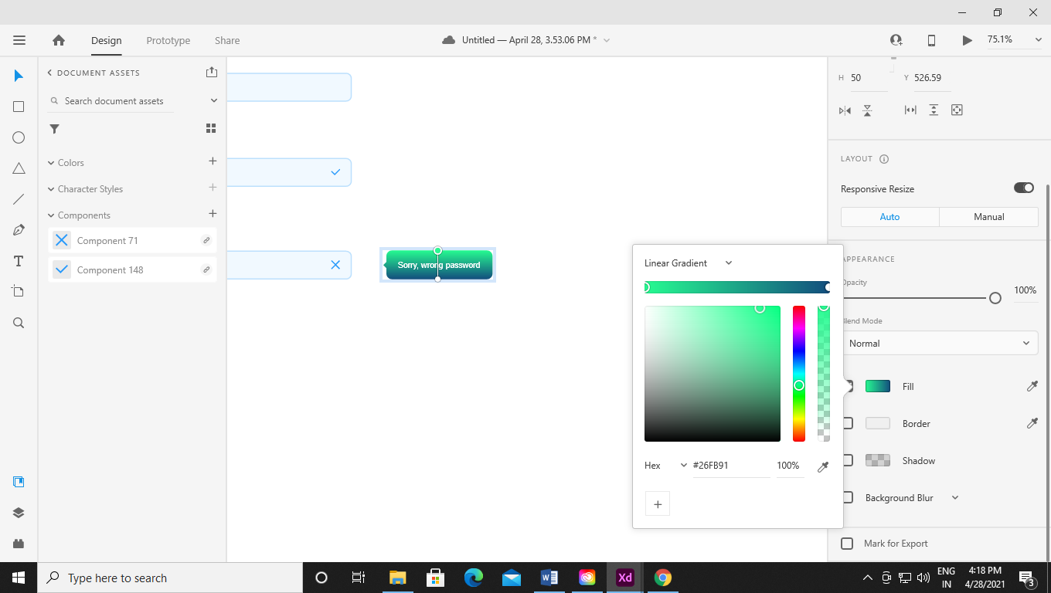

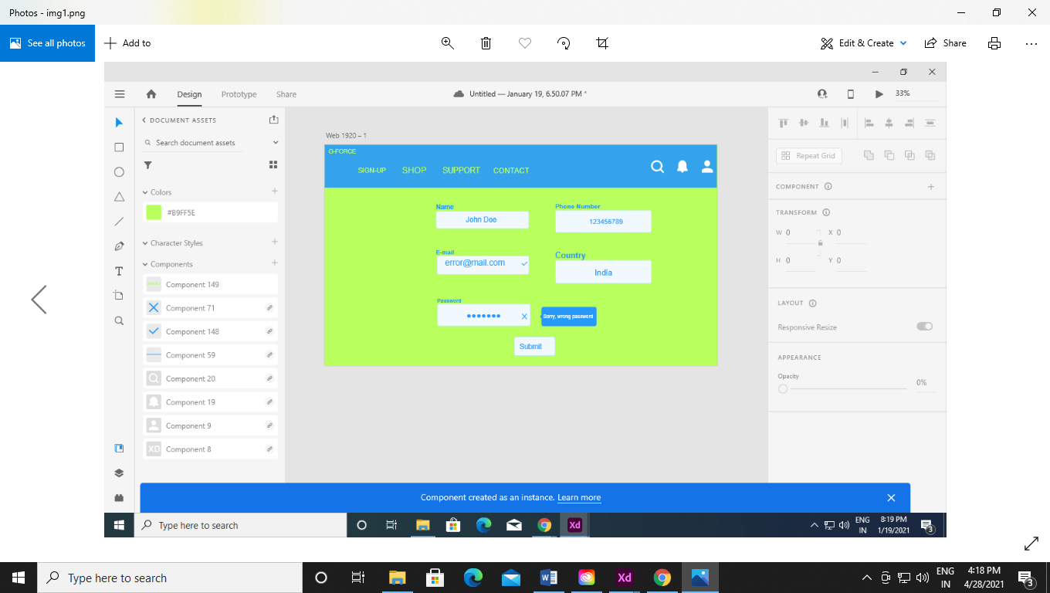

Experiment 3:-

Aim:- Prototyping work created on Adobe XD.

Scenario:-

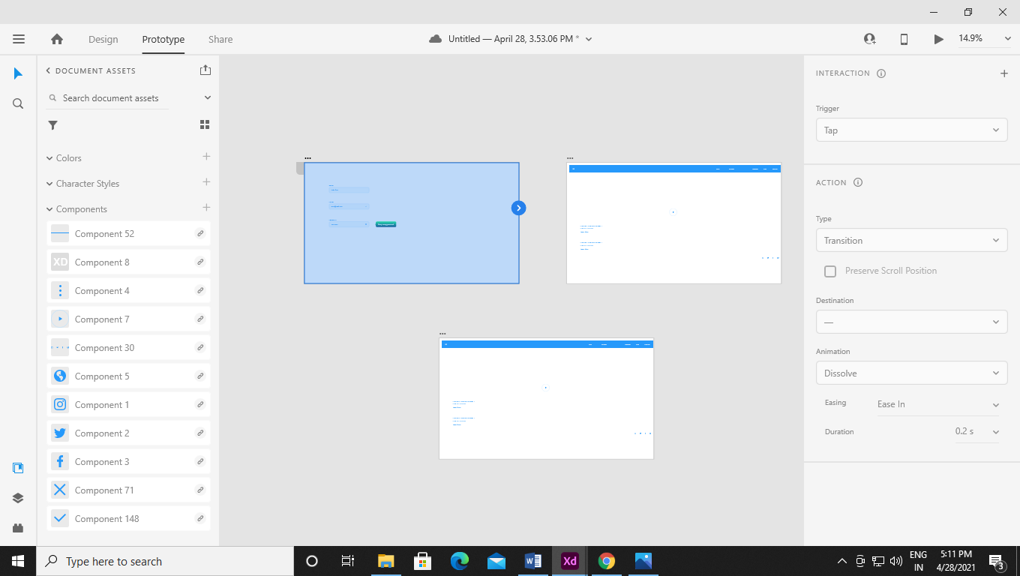

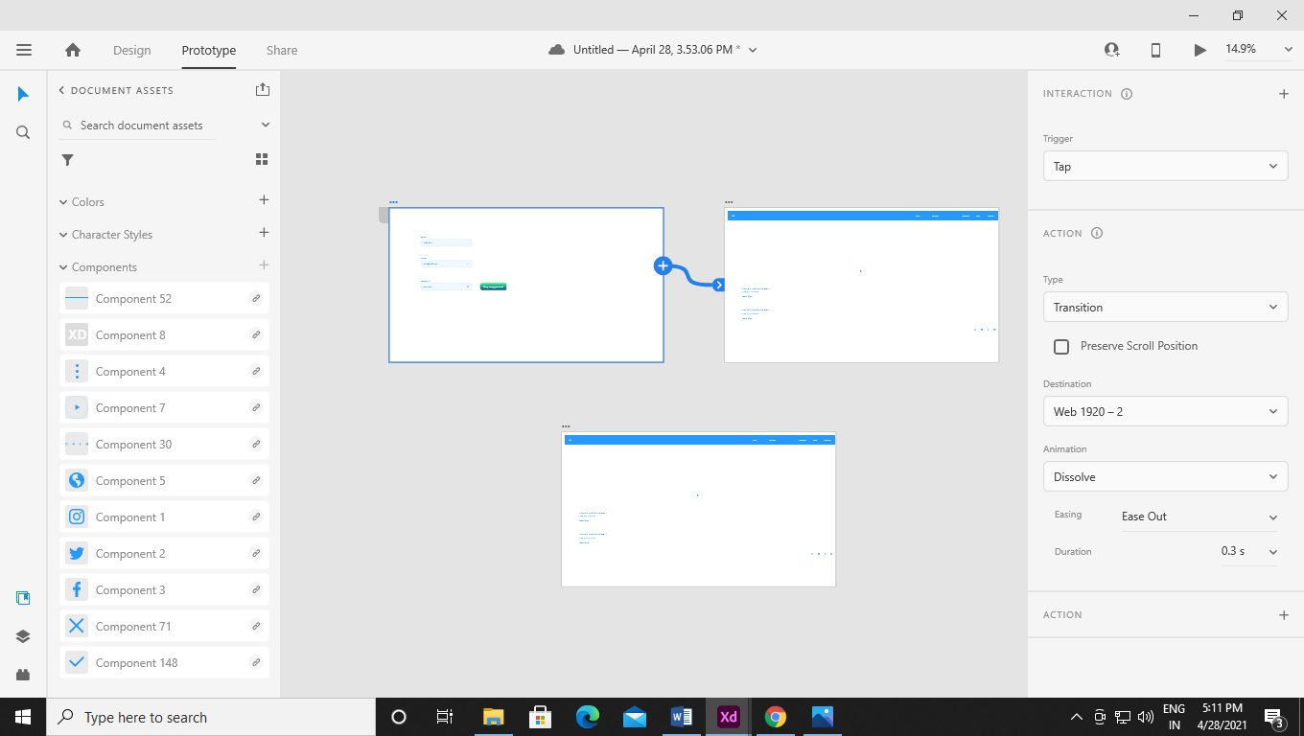

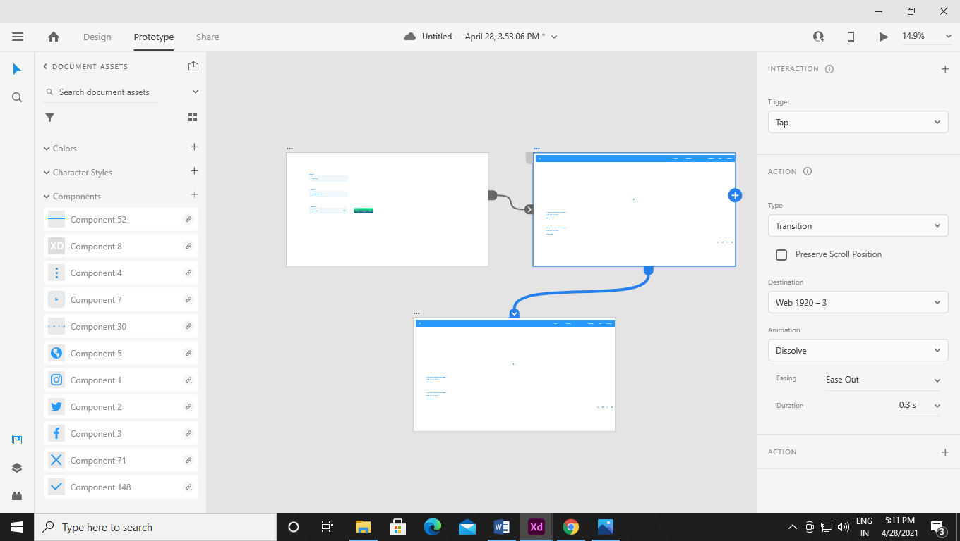

Experiment 4:-

Aim:- Use of Slider tool.

Scenario:-

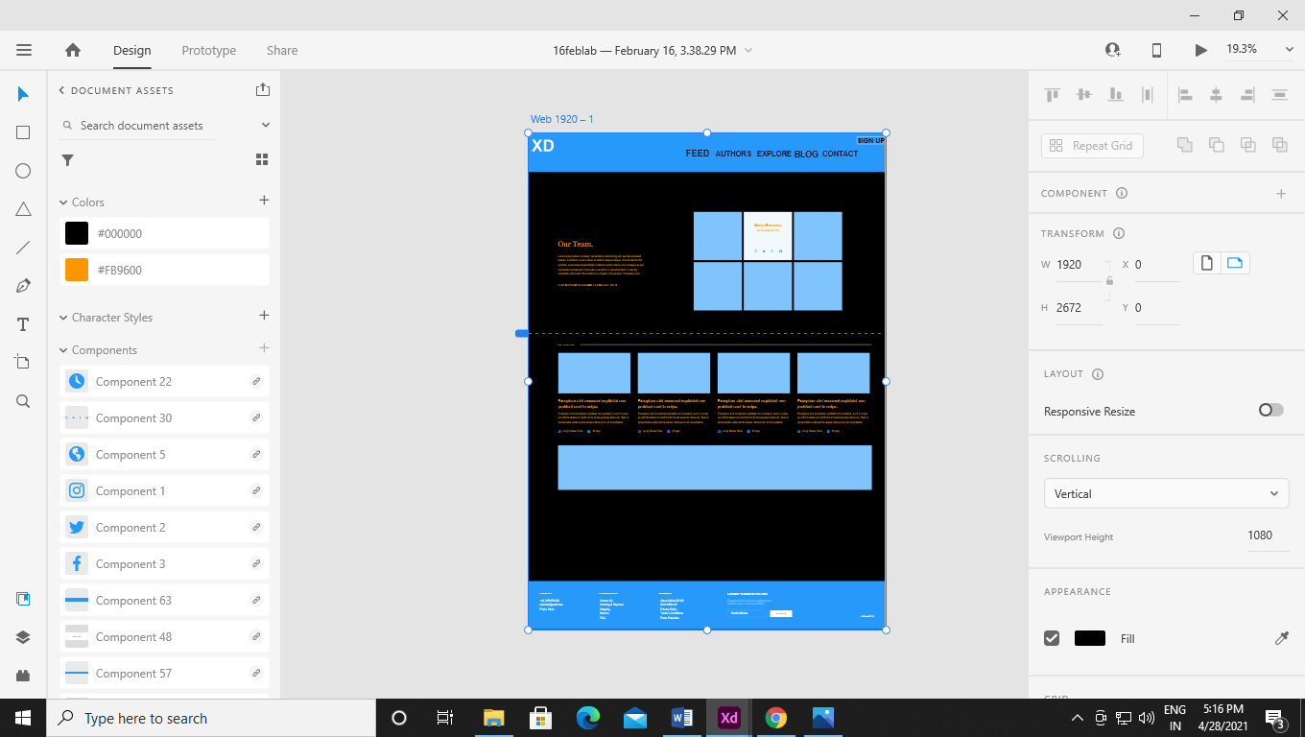

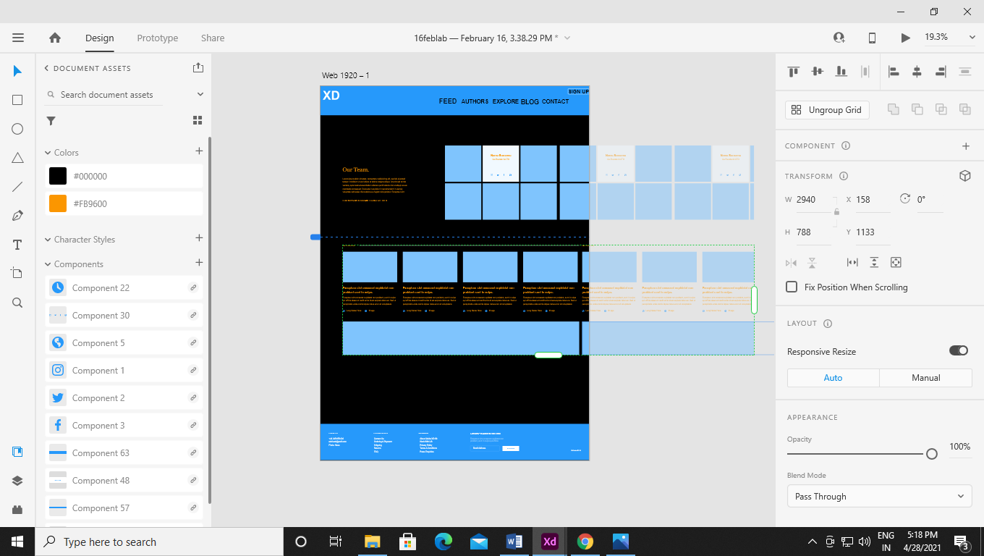

Project

**Aim:-** Creating website through the Adobe Xd using wireframes GUI kits tools etc.

**Work:-**

**Login Page:-**

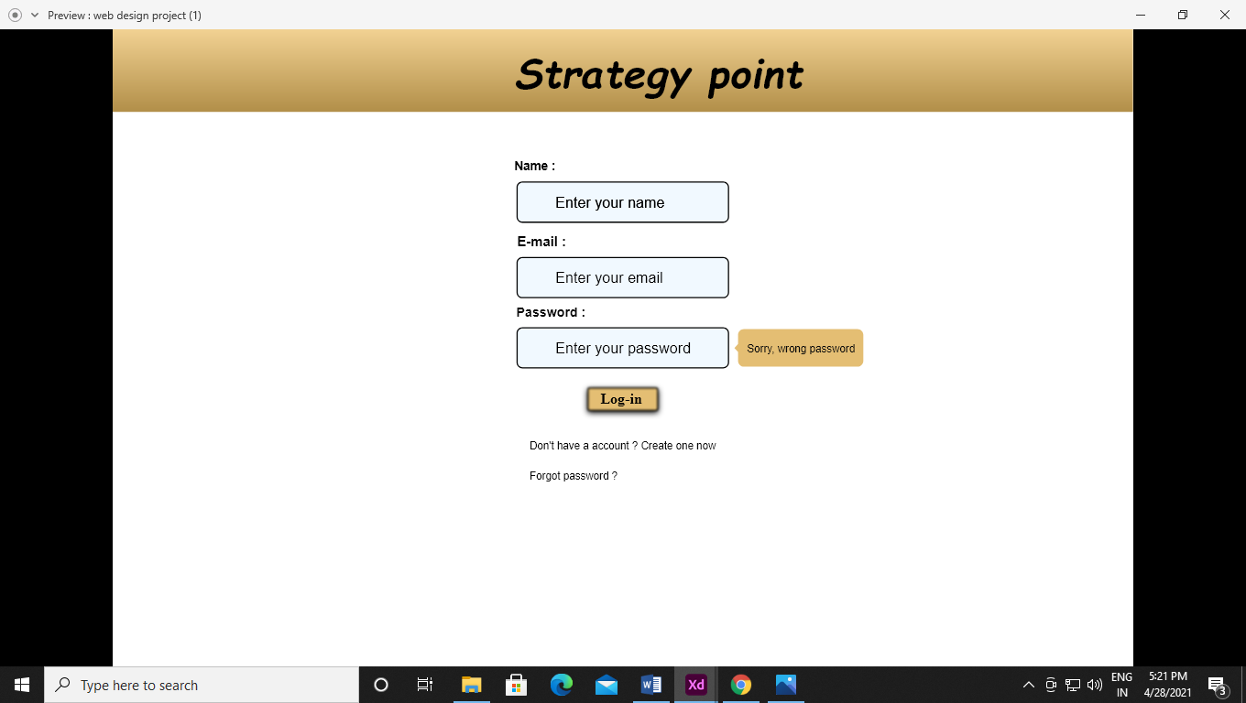

Account Creation Page:-

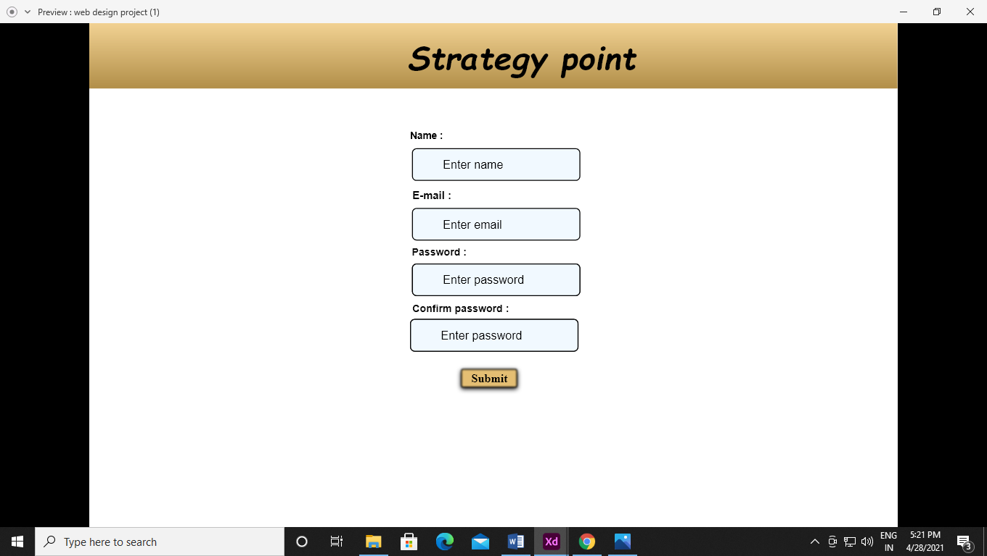

Password Re-creation page:-

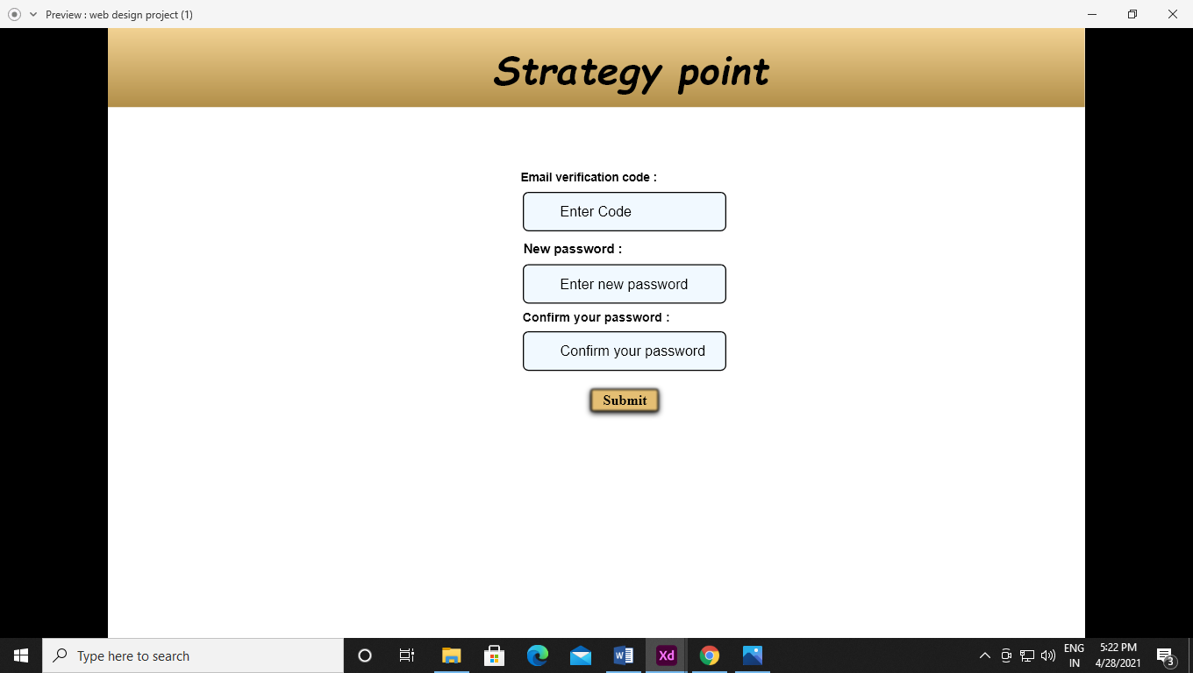

Home Page(Landing Page):-

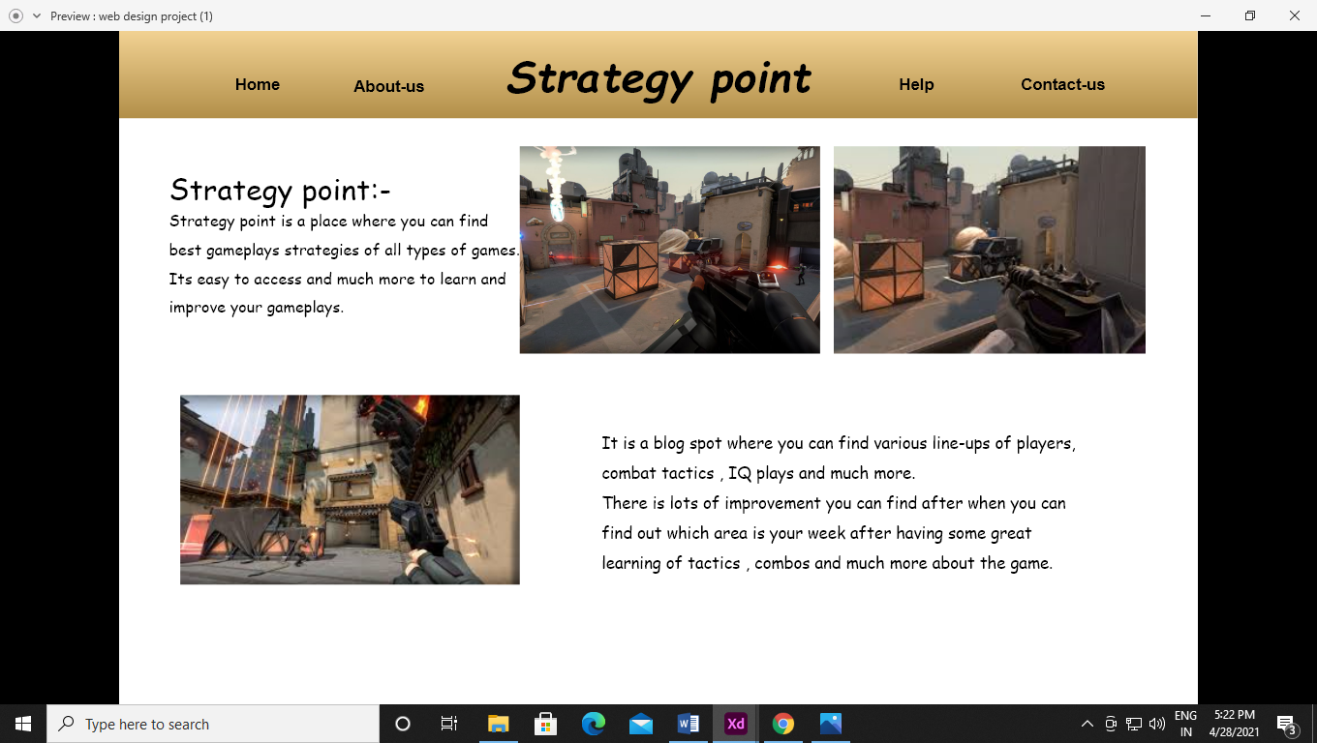

About Us:-

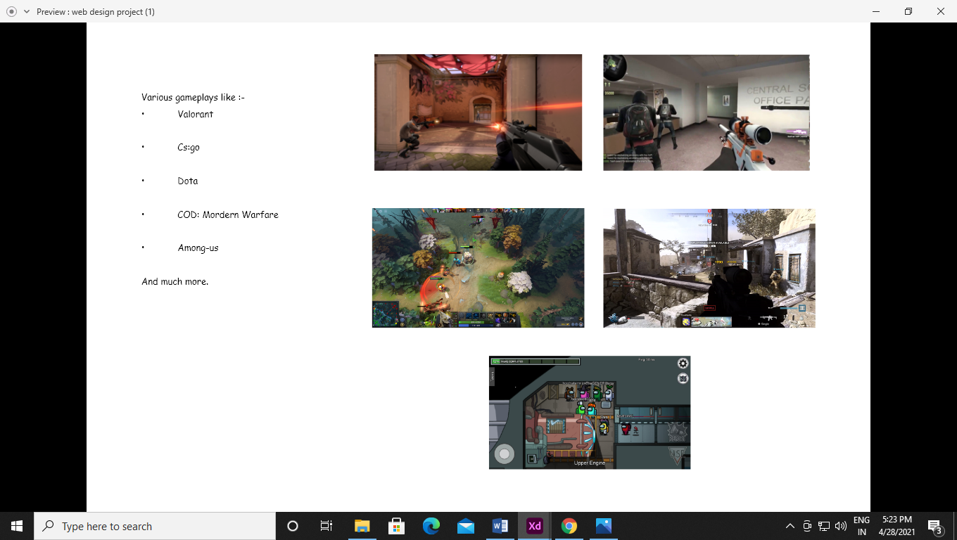

End Page:-

